Running Asynchronous Replica-Exchange Simulations Across Heterogeneous Distributed Infrastructures

Authors: Abhinav Thota^{1, 2}, Wei Huang¹, Andre Luckow¹, Shantenu Jha^{1, 2, 3}

¹Center for Computation & Technology, Louisiana State University, USA
²Department of Computer Science, Louisiana State University, USA
³e-Science Institute, University of Edinburgh, UK

Abstract: In this work, we focus on the Replica-Exchange (RE) [1, 2] methods – which represent a class of algorithms that involve a large number of loosely coupled ensembles. We develop a flexible, extensible and scalable implementation of RE that can utilize a range of infrastructure concurrently (and autonomically/adaptively), that supports different coordination mechanisms (publish-subscribe, centralized notification), different replica pairing mechanisms (synchronous versus asynchronous) and thereby different variants of the RE algorithm.
Keywords: distributed production infrastructure, novel algorithm, effective coordination

- Introduction

Developing applications that are able to orchestrate heterogeneous resources across distributed resources is a complex task. Inevitably, the design and development of an application is influenced and constrained by the programming systems and the infrastructure it is developed against. Breaking this coupling between the development and the underlying infrastructure, to enable applications to be flexible (across infrastructure), extensible (to new methods of communication and coordination) and scalable is an important design objective of distributed applications – both logically distributed and physically distributed. In this work, we focus on the Replica-Exchange (RE) [1, 2] methods – which represent a class of algorithms that involve a large number of loosely coupled ensembles. RE simulations are used to understand physical phenomena – ranging from protein folding dynamics to binding affinity calculations. We develop a flexible, extensible and scalable implementation of RE that can utilize a range of infrastructure concurrently (and autonomically/adaptively), that supports different coordination mechanisms (publish-subscribe, centralized notification), different replica pairing mechanisms (synchronous versus asynchronous) and thereby different variants of the RE algorithm. We implement and demonstrate how a flexible and robust implementation enables the efficient use of a broad range of infrastructure.

2. Replica-Exchange Approach
The RE algorithm involves the concurrent execution of multiple similar simulations, the replicas. There is a loose coupling between the replicas in form of periodic exchange attempts between paired replicas.
2.1 Traditional Replica Exchange
For the vanilla implementation of RE (Case I), depending on the number of processes N, the manager creates N/2 pairs of replicas. When the replicas reach a pre-determined state (e.g. the NAMD job finishes after a fixed number of steps), a decision as to whether to exchange temperatures between previously paired replicas is determined using the Metropolis scheme. The run of an ensemble of replicas in parallel and the subsequent pair wise exchange attempt are referred to as generation. No two replicas can belong to different generations. If the exchange attempt is successful, parameters such as the temperature are swapped. Both jobs are then re-launched. A major limitation of this model is that the replicas are paired in fixed groups. Exchanges can only take place between these paired replicas. This, while limiting the number of replicas which are available for an exchange, also inhibits exchanges between replicas with non-nearest temperatures. This also negates the possibility of crosswalks. A crosswalk is said to occur when a replica originally with a low temperature reaches the upper temperature range and then returns to the lower temperature range. Replica pairing works well in an ideal scenario but with heterogeneous systems, where the resource availability fluctuates, it is far from ideal. It is important to have a scheme that does not depend on a static, well-defined model of resource availability. This forms the motivation for coming up with a formulation that makes it possible to run RE simulations on a range of infrastructures.
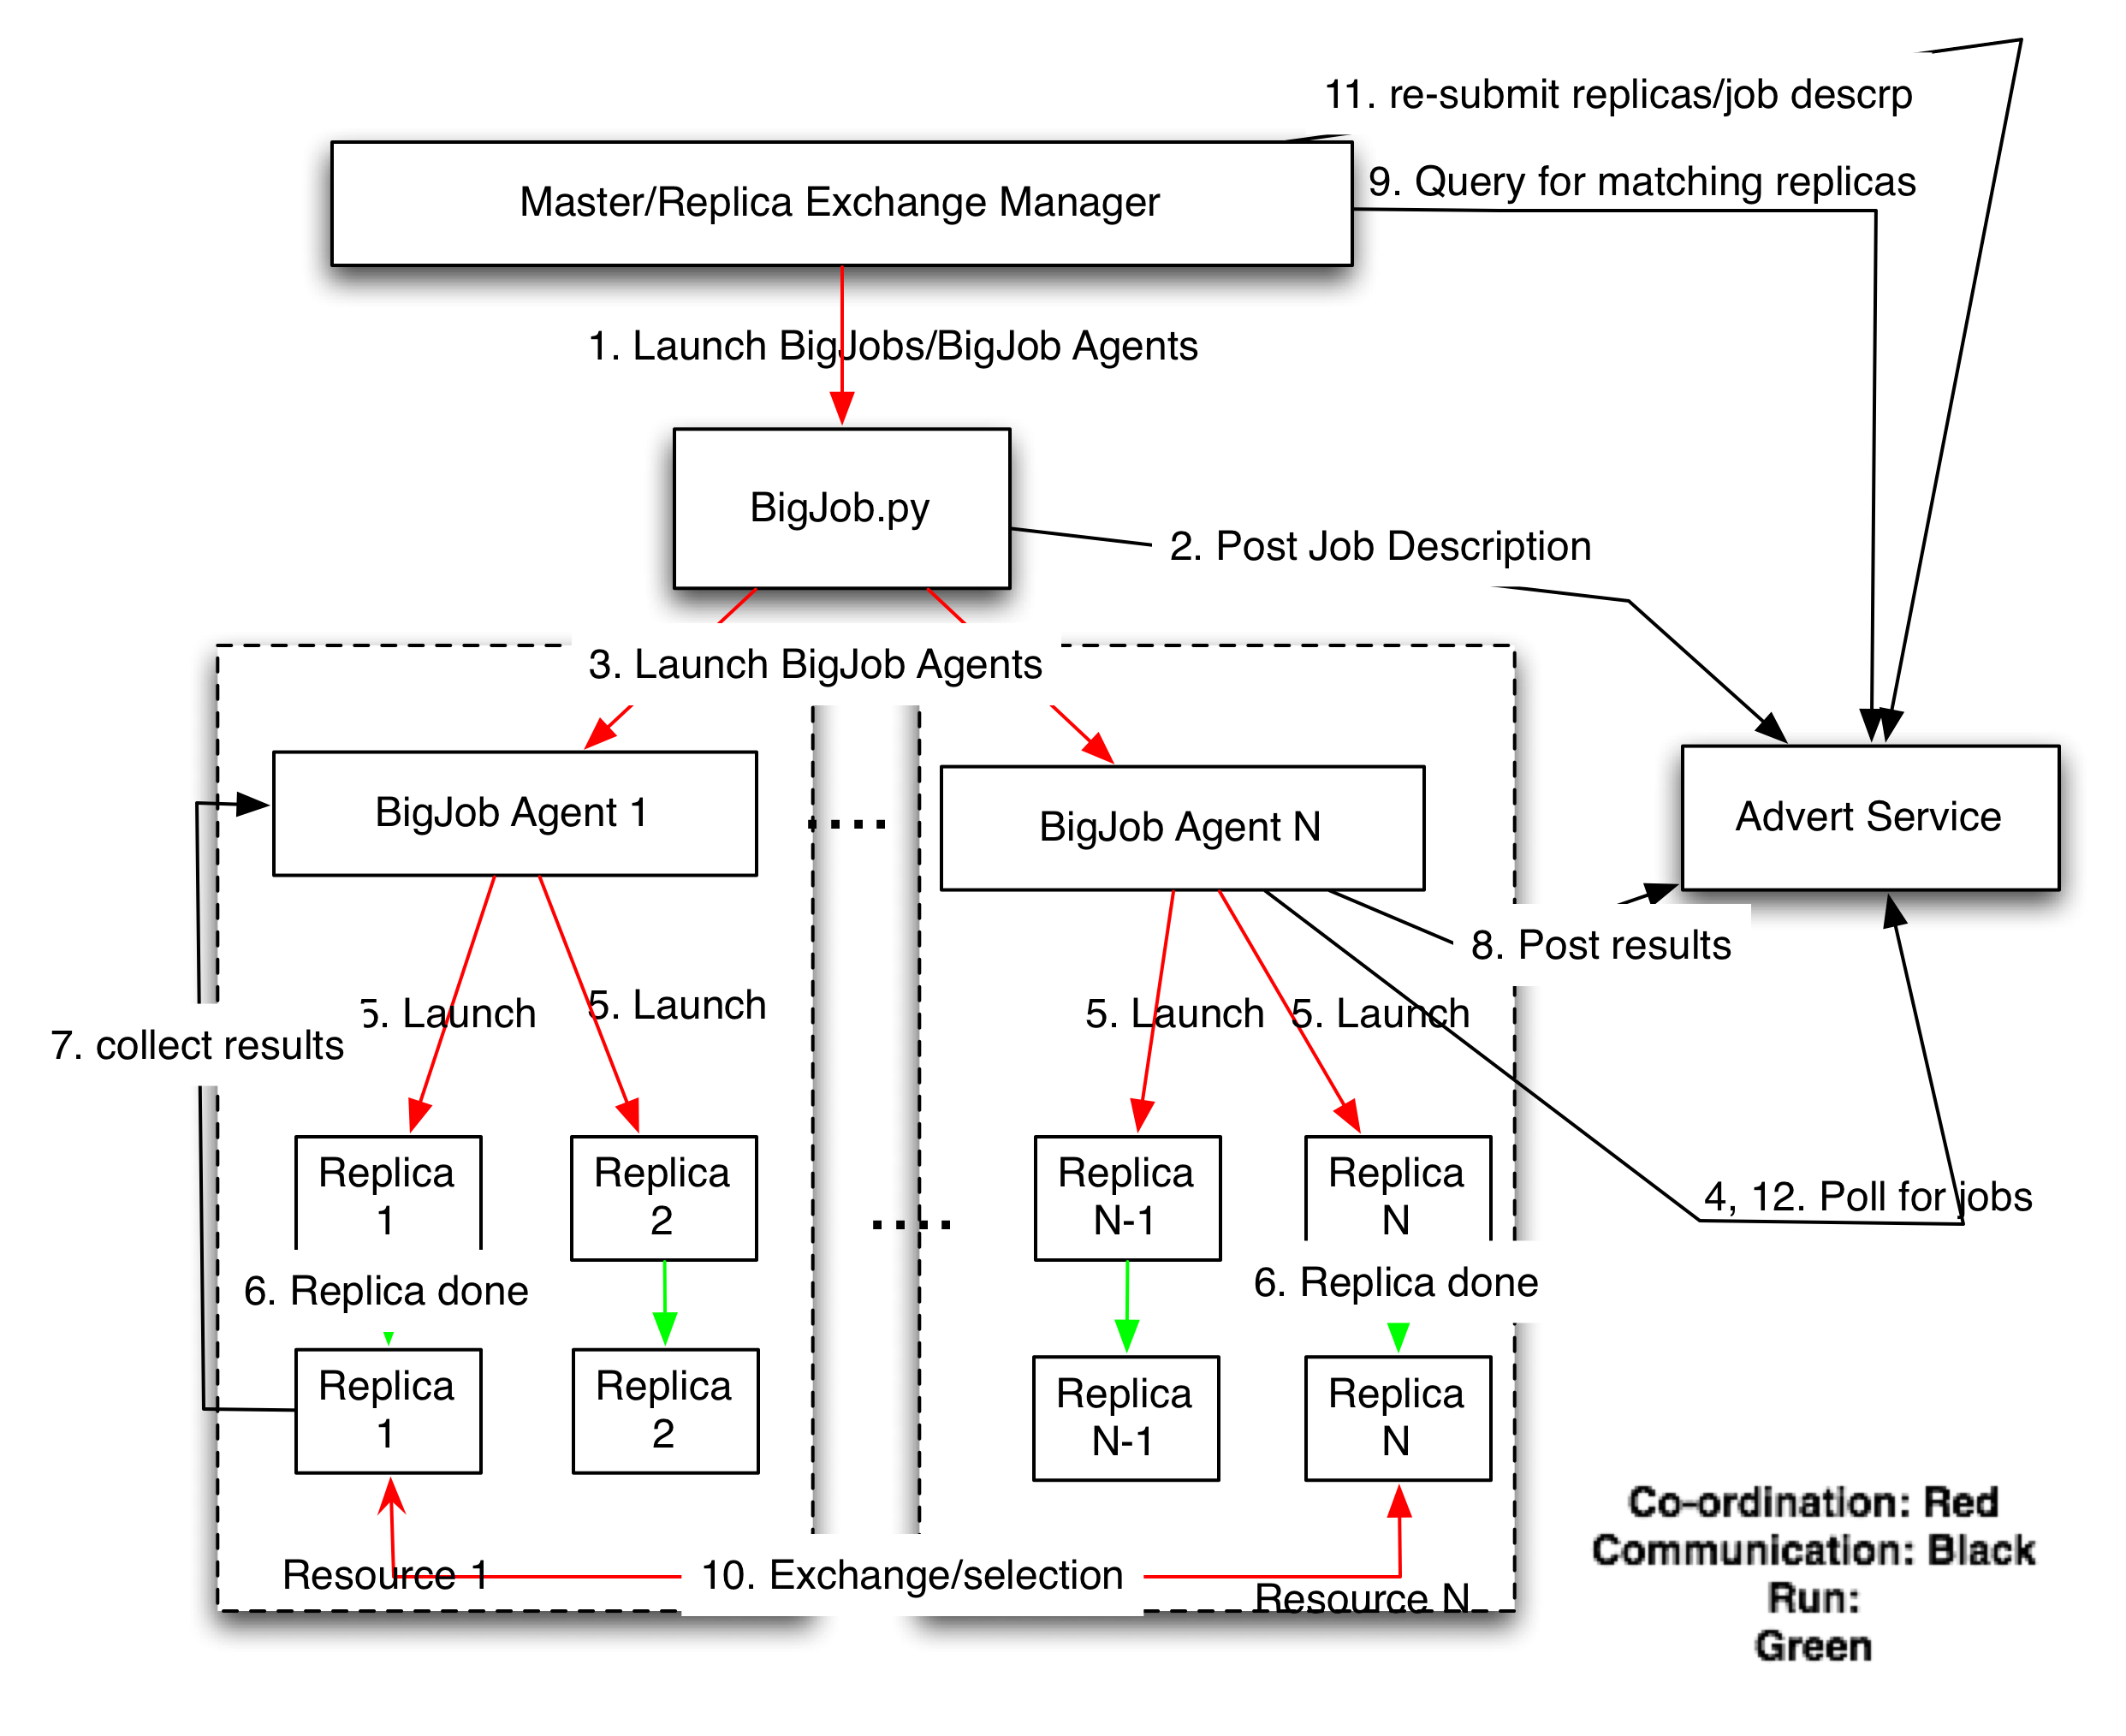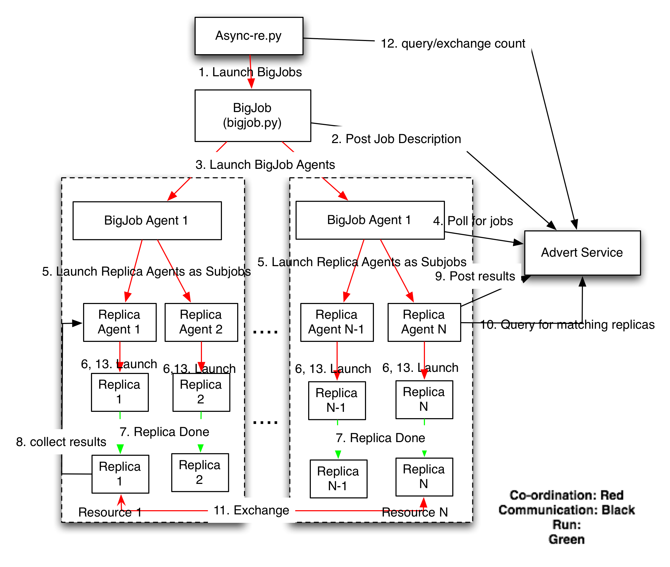
Figure 1: Control flow of centralized asynchronous RE (Figure 1(a)) and control flow of decentralized asynchronous RE version (Figure 1(b))

2.2 Asynchronous Replica Exchange

We propose an asynchronous RE algorithm similar to Parashar et al. [7] where a replica can perform exchanges asynchronously with any other replica in the ensemble. This eliminates the need to pair the replicas and limit exchanges to fixed pairs of replicas. We differ from the model described in Parashar et al. in some important ways. The asynchronous RE model we developed runs on production level grids such as the Teragrid and LONI [8], unlike a specialized infrastructure such as CometG. Also, we run the replicas as MPI jobs. We present two variants of the Asynchronous RE algorithm. The first is a centralized mechanism where a master manages all the replicas. The second is a decentralized mechanism where each replica is managed independently, in a decoupled manner.
2.2.1 Centralized Asynchronous RE
In the centralized version (Figure 1(a)) of the asynchronous replica exchange (Case II), the master launches and monitors the replicas. As and when it finds a replica in done state, the master starts searching for an appropriate partner from any other replicas in done state. The decision as to make the exchange or not is made using the Metropolis scheme. After each successful exchange the master re-launches the replicas involved in the exchange and continues to monitor the replicas.
2.2.2 Decentralized Asynchronous RE
In the decentralized version (Case III) version (Figure 1(b)), an agent is launched for each replica. The agent then runs and monitors the replica and looks for partners to exchange when appropriate. In this case, the agent carries out the various tasks needed to conduct the exchange. Although both Case II and Case III implement the asynchronous RE algorithm, they differ subtly. The replicas are either managed by a master (Case II) or each replica is managed individually (Case III). We propose Case III so as to not let the centralized master become a bottleneck, which can happen very quickly with a large number of replicas.
3. SAGA BigJob - A Pilot-job Framework
The Simple API for Grid Applications (SAGA) [5] is an API standardization effort within the Open Grid Forum (OGF) [6], an international standards development body concerned primarily with standards for distributed computing. The various tasks that are carried out using the SAGA APIs include file staging, job spawning and the conduction of the exchange attempts. Previously, we demonstrated the usage of the SAGA Pilot-Job framework [3] – called the BigJob, to run RE simulations across multiple, heterogeneous, distributed Grid and Cloud infrastructures [4]. Here we are using the SAGA BigJob to efficiently request and manage computational resources.
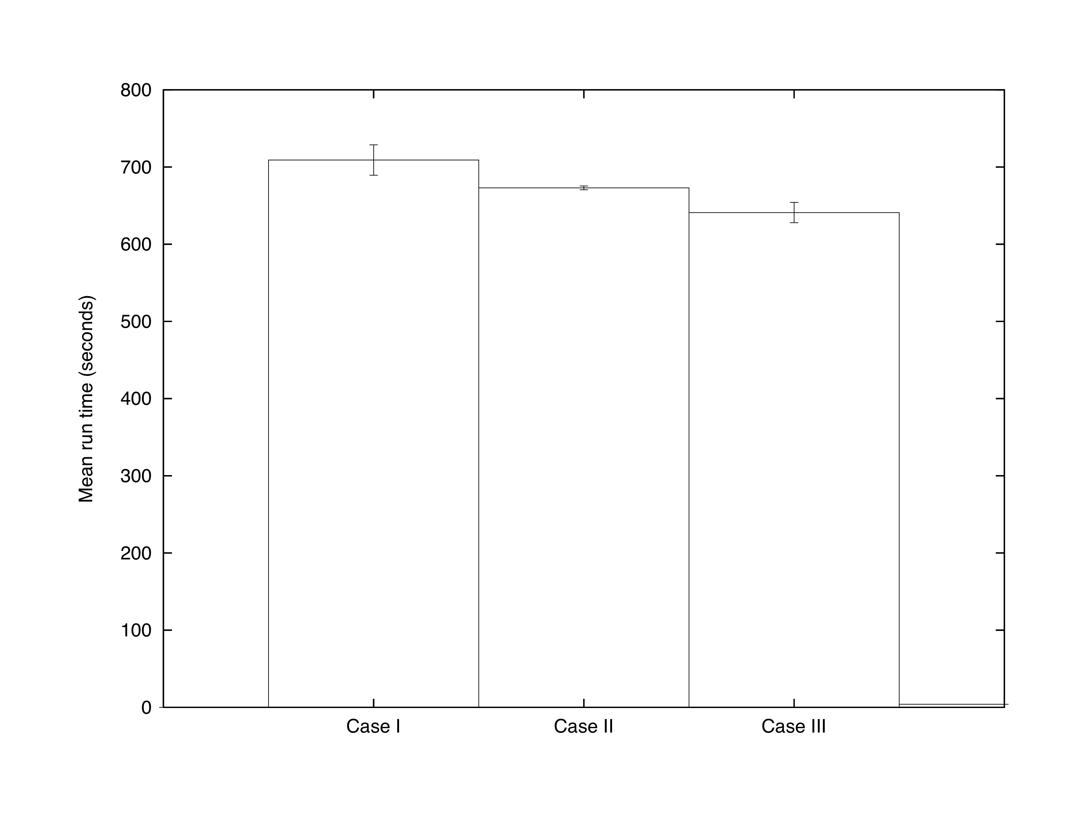
Figure 2: The graph shows the mean run times of synchronous and asynchronous - centralized and asynchronous -decentralized RE simulations. In each case, one 64 core BigJob was launched and was assigned 4 replicas. The size of each replica is 16 cores. Each experiment has been repeated at least 6 times. Improved run times can be observed in asynchronous RE simulations. This is due to the overhead involved in synchronizing and sequentially restarting the replicas after each exchange. The standard errors are 19, 2 and 13 respectively.

4. Analysis

We configured both the Cases I, II & III to run a parallel NAMD simulation with 4 replicas sampling a temperature between 300 and 450 K on QueenBee, a LONI machine. One 64 core BigJob is launched and each replica uses 16 MPI processes and runs 500 time steps between exchange attempts. The metric used is the time to complete 16 attempted exchanges. The mean run time is obtained by subtracting the queue wait time of the BigJob from the total time. To understand the performance gains (Figure 2) we need to understand the logic behind synchronous and asynchronous RE and how it inevitably influences the implementation. Ideally, synchronous RE should perform better than asynchronous RE. But, in Case I, the master alone manages the whole simulation. And when it comes to re-launching the replicas after the exchange step, there is always a gap between the time the first replica is re-launched and the last replica re-launched. The gap only grows with more number of replicas. In Case II, the master only has to re-launch two replicas at any one time. In Case III, the each replica has its own manager and this eliminates the delays caused by a central master. This is the difference that we see in the graph.
5. Conclusion
An important motivation for this work is to implement a scheme that does not depend on a static, well-defined model of resource availability. Preliminary results, shown in Figure 2, indicate the most important advantages of asynchronous RE and SAGA/BigJob over traditional RE: (a) a reduced time to completion when running on more than one machine due to improved resource availabilities, (b) the advantage of using a pilot-job mechanism, which eliminates the waiting times at the local resource manager, and (c) the ability to scale out across different production level infrastructure, such as, the Teragrid and LONI. Further, we will compare the traditional RE model(Case I) and the centralized(Case II) and decentralized(Case III) models of the asynchronous replica exchange by modeling and repeating the experiments a reasonable number of times, so as to accurately quantify the scientific and performance gains.
6. Acknowledgments
The current work is funded by the NSF EPSCoR CyberTools project under award #EPS-0701491.

7. References

[1] U. Hansmann, “Parallel Tempering Algorithm for Conformational Studies of Biological Molecules,” in Chemical Physics Letters, vol. 281, 1997, pp. 140–150.
[2] Y. Sugita and Y. Okamoto, “Replica-Exchange Molecular Dynamics Method for Protein Folding,” in Chemical Physics Letters, vol. 314, 1999, pp. 141–151.
[3] A. Luckow, L. Lacinski, and S. Jha, “Saga bigjob: An extensible and interoperable pilot-job abstraction for distributed applications and systems,” in The 10th IEEE/ACM International Symposium on Cluster, Cloud and Grid Computing, 2010.
[4] A. Luckow, S. Jha, J. Kim, A. Merzky, and B. Schnor, “Adaptive Replica-Exchange Simulations,” Royal Society Philosophical Transactions A, 2009.
[5] T. Goodale, S. Jha, H. Kaiser, T. Kielmann, P. Kleijer, A. Merzky, J. Shalf, and C. Smith, “A Simple API for Grid Applications (SAGA),” OGF Document Series 90, http://www.ogf.org/documents/GFD.90.pdf.
[6] Open Grid Forum. [Online]. Available: http://www.ogf.org/
[7] Z. Li and M. Parashar, “Grid-based asynchronous replica exchange,” in GRID ’07: Proceedings of the 8th IEEE/ACM International Conference on Grid Computing. Washington, DC, USA: IEEE Computer Society,
2007, pp. 201–208.
[8] Louisiana Optical Network Initiative, http://www.loni.org/.

